

Semester One Examination, 2020

Question/Answer Booklet

MATHEMATICS
METHODS
ATAR Year 12
Section Two:
Calculator-assumed

Student Name: SOLUTIONS

Please circle your teacher’s name
Teacher: Miss Long Miss Rowden Ms Stone

Time allowed for this paper
Reading time before commencing work: 10 minutes
Working time for paper: 100 minutes

Materials required/recommended for this paper
To be provided by the supervisor
Number of additional
answer booklets used
(if applicable):
This Question/Answer Booklet
Formula Sheet (retained from Section One)

To be provided by the candidate
Standard items: pens (blue/black preferred), pencils (including coloured), sharpener, correction fluid/tape, eraser, ruler, highlighters
Special items: drawing instruments, templates, notes on two unfolded sheets of A4 paper, and up to three calculators approved for use in this examination

Important note to candidates
No other items may be taken into the examination room. It is your responsibility to ensure that you do not have any unauthorised material. If you have any unauthorised material with you, hand it to the supervisor before reading any further.
Structure of this paper
Section | Number of questions available | Number of questions to be answered | Suggested working time (minutes) | Marks available | Percentage of examination
Section One:  Calculator free | 8 | 8 | 50 | 52 | 35
Section Two:  Calculator-assumed | 13 | 13 | 100 | 97 | 65
 |  |  |  | Total | 100

Instructions to candidates
- The rules for the conduct of the ATAR course examinations are detailed in the Year 12 Information Handbook 2020. Sitting this examination implies that you agree to abide by these rules.

- Write your answers in this Question/Answer booklet.

- You must be careful to confine your answers to the specific questions asked and to follow any instructions that are specific to a particular question.

- Supplementary pages for the use planning/continuing your answer to a question have been provided at the end of the Question/Answer booklet. If you use these pages to continue an answer, indicate at the original answer where the answer is continued, i.e. give the page number.

- Show all your working clearly. Your working should be in sufficient detail to allow your answers to be checked readily and for marks to be awarded for reasoning. Incorrect answers given without supporting reasoning cannot be allocated any marks. For any question or part question worth more than two marks, valid working or justification is required to receive full marks. If you repeat any question, ensure that you cancel the answer you do not wish to have marked.

- It is recommended that you do not use pencil, except in diagrams.

- The Formula sheet is not to be handed in with your Question/Answer booklet.

Section Two: Calculator-assumed 65% (97 Marks)

This section has thirteen (13) questions. Answer all questions. Write your answers in the spaces
provided.

Supplementary pages for the use of planning/continuing your answer to a question have been provided at the end of this Question/Answer booklet. If you use these pages to continue an answer, indicate at the original answer where the answer is continued, i.e. give the page number.

Working time: 100 minutes.

Question 9 (4 marks)
The graphs of $y=\cos^{2}\left(x+\frac{π}{6}\right)$ and $y=\frac{3}{4}$ are shown below. Determine the exact area of the shaded region they enclose.

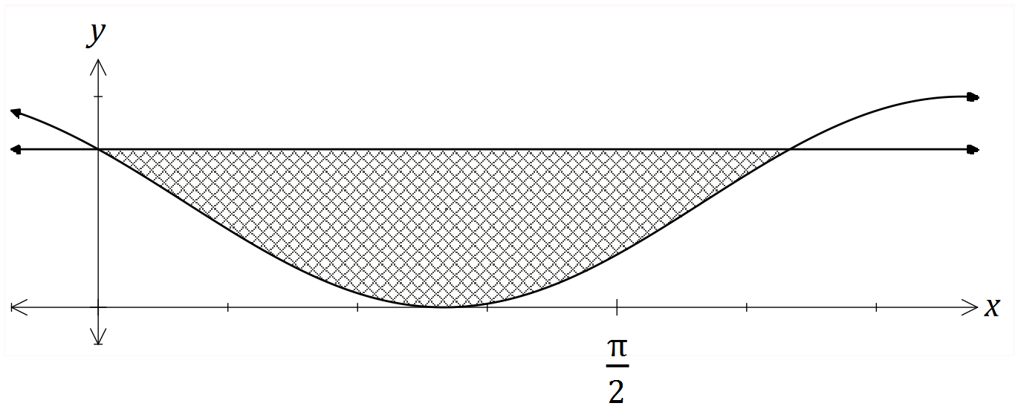

Solution
$$\cos^{2}\left(x+\frac{π}{6}\right)=\frac{3}{4}⇒x=0,\frac{2π}{3} \\ A=\int_{0}^{2π/3}{\frac{3}{4}-\cos^{2}\left(x+\frac{π}{6}\right)} dx \\ A=\frac{π}{6}+\frac{\sqrt{3}}{4} \text{sq units}$$

Specific behaviours
solves intersection of functions
writes required integral
uses exact values throughout
evaluates integral exactly

Question 10 (8 marks)
A small body moving in a straight line has displacement $x$ cm from the origin at time $t$ seconds given by
$$x=8\cos\left(0.5t-2\right)+1.5, 0≤t≤12.$$
(a) Use derivatives to justify that the maximum displacement of the body occurs when $t=4$.
(4 marks)
Solution
$$\frac{dx}{dt}=-4\sin\left(0.5t-2\right) \\ t=4⇒\frac{dx}{dt}=-4\sin\left(0\right)=0$$
Hence when $t=4, x$ has a stationary point.

$$\frac{d^{2}x}{dt^{2}}=-2\cos\left(0.5t-2\right) \\ t=4⇒\frac{d^{2}x}{dt^{2}}=-2\cos\left(0\right)=-2$$
Since second derivative is negative, the stationary point is a maximum, and so the body has a maximum displacement when $t=4$.

Specific behaviours
first derivative
✓ indicates stationary point at required time
✓ value of second derivative at required time
✓ statement that justifies maximum

(b) Determine the time(s) when the velocity of the body is not changing. (2 marks)
Solution
$$a=\frac{d^{2}x}{dt^{2}}=-2\cos\left(0.5t-2\right)$$
$$a=0⇒\cos\left(0.5t-2\right)=0$$

$$t=-π+4, π+4≈0.858, 7.142 \text{seconds}$$

Specific behaviours
indicates acceleration/second derivative must be zero
✓ states exact (or approximate) times in interval

(c) Express the acceleration of the body in terms of its displacement $x$. (2 marks)
Solution
$$a=-2\cos\left(0.5t-2\right) \\ =-0.25\left(8\cos\left(0.5t-2\right)\right) \\ =-0.25\left(x-1.5\right)$$

Specific behaviours
factors out $-0.25$
✓ correct expression

Question 11 (8 marks)
The voltage, $V$ volts, supplied by a battery $t$ hours after timing began is given by
$$V=8.95e^{-0.265t}$$

(a) Determine
Solution
$$V\left(0\right)=8.95 \text{V}$$
Specific behaviours
correct value

(i) the initial voltage. (1 mark)

Solution
$$V\left(3\right)=4.04 \text{V}$$
Specific behaviours
correct value

(ii) the voltage after $3$ hours. (1 mark)

(iii) the time taken for the voltage to reach $0.03$ volts. (1 mark)
Solution
$$t=21.5 \text{h}$$
Specific behaviours
correct value

(b) Show that $\begin{matrix}dV \\ \overline{dt}\end{matrix}=aV$ and state the value of the constant $a$. (2 marks)
Solution
$$\frac{dV}{dt}=-0.265\left(8.95e^{-0.265}\right) \\ =aV$$

$$a=-0.265$$
Specific behaviours
correct derivative
✓ value of $a$

(c) Determine the rate of change of voltage $3$ hours after timing began. (1 mark)
Solution
$$\dot{V}=-0.265×4.04=-1.07 \text{V/h}$$
Specific behaviours
correct rate

(d) Determine the time at which the voltage is decreasing at $5\%$ of its initial rate of decrease.
(2 marks)
Solution
$$\dot{V}∝V⇒e^{-0.265t}=0.05$$

$$t=11.3 \text{h}$$

Specific behaviours
indicates suitable method
✓ correct time

Question 12 (7 marks)
The function $f$ is defined as $f\left(x\right)=\begin{matrix}5e^{0.125x} \\ \overline{ x }\end{matrix} , x>0$, and the graph of $y=f(x)$ is shown below.
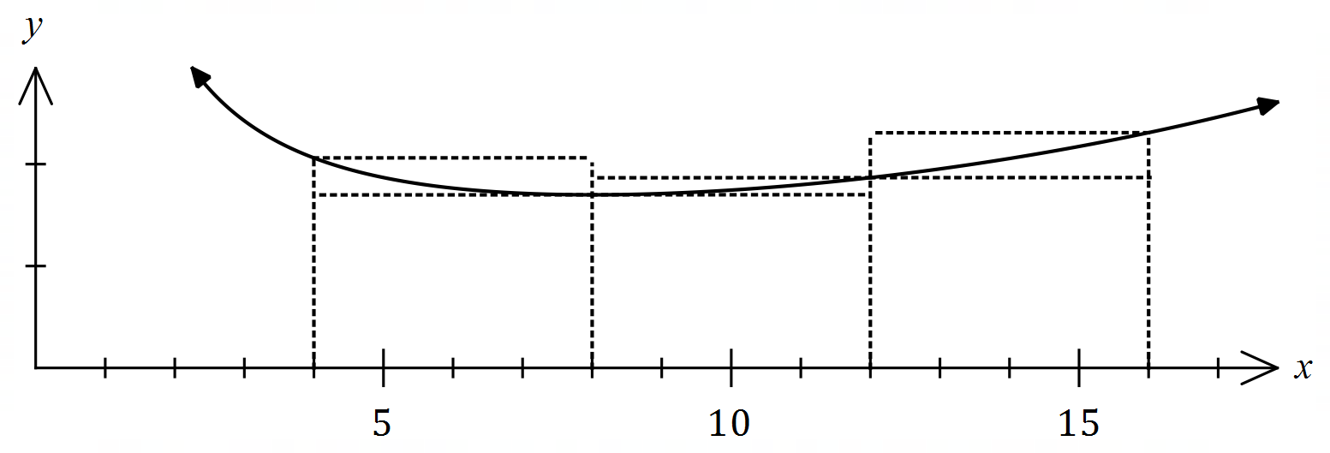
(a) Complete the missing values in the table below, rounding to $2$ decimal places.
(1 mark)
Solution
See table
Specific behaviours
both correct

$$x$$ | $$4$$ | $$8$$ | $$12$$ | $$16$$
$$f(x)$$ | $$2.06$$ | $$1.70$$ | $$1.87$$ | $$2.31$$

(b) Use the areas of the rectangles shown on the graph to determine an under- and over-estimate for $\int_{4}^{16}{\underset{ }{\overset{ }{f(x)}}}dx$. (3 marks)
Solution
$$U=4\left(1.70+1.70+1.87\right)=4×5.27=21.08$$

$$O=4\left(2.06+1.87+2.31\right)=4×6.24=24.96$$

Specific behaviours
indicates $δx=4$
✓ under-estimate
✓ over-estimate

(c) Use your answers to part (b) to obtain an estimate for $\int_{4}^{16}{\underset{ }{\overset{ }{f(x)}}}dx$. (1 mark)
Solution
$$E=\left(21.08+24.96\right)÷2≈23.0$$

Specific behaviours
correct mean

(d) State whether your estimate in part (c) is too large or too small and suggest a modification to the numerical method employed to obtain a more accurate estimate. (2 marks)
Solution
Estimate is too large ($f(x)$ is concave upwards).

Better estimate can be found using a larger number of thinner rectangles.

Specific behaviours
states too big
✓ indicates modification to improve estimate

Question 13 (7 marks)
Functions $f$ and $g$ are such that

$$f\left(4\right)=2, f^{'}\left(x\right)=18{\left(3x-10\right)}^{-2}$$

$$g\left(-4\right)=2, g^{'}\left(x\right)=18{\left(3x+10\right)}^{-2}$$

(a) Determine $f(6)$. (3 marks)
Solution
$$f\left(6\right)=f\left(4\right)+\int_{4}^{6}{18{\left(3x-10\right)}^{-2}}dx \\ =2+{\left[\frac{-6}{3x-10}\right]}_{4}^{6} \\ =2+\left(-\frac{3}{4}-(-3)\right) \\ =\frac{17}{4}=4\frac{1}{4}$$

Specific behaviours
integrates rate of change
✓ determines change
✓ correct value

(b) Use the increments formula to determine an approximation for $g(-3.98)$. (3 marks)
Solution
$$x=-4, δx=0.02$$

$$δy≈\frac{18}{{\left(3x+10\right)}^{2}}×δx \\ ≈\frac{18}{4}×0.02≈0.09$$

$$g\left(-3.95\right)≈2+0.09≈2.09$$

Specific behaviours
values of $x$ and $δx$
✓ use of increments formula
✓ correct approximation

(c) Briefly discuss whether using the information given about $f$ and the increments formula would yield a reasonable approximation for $f(6)$. (1 mark)
Solution
No, approximation wouldn't - the change $δx=2$ is not a small change. (NB Yields $f\left(6\right)≈11$ )
Specific behaviours
states no with reason

Question 14 (9 marks)
A small body leaves point $P$ and travels in a straight line for $24$ seconds until it reaches point $Q$. The velocity $v$ m/s of the body is shown in the graph below for $0≤t≤24$ seconds.
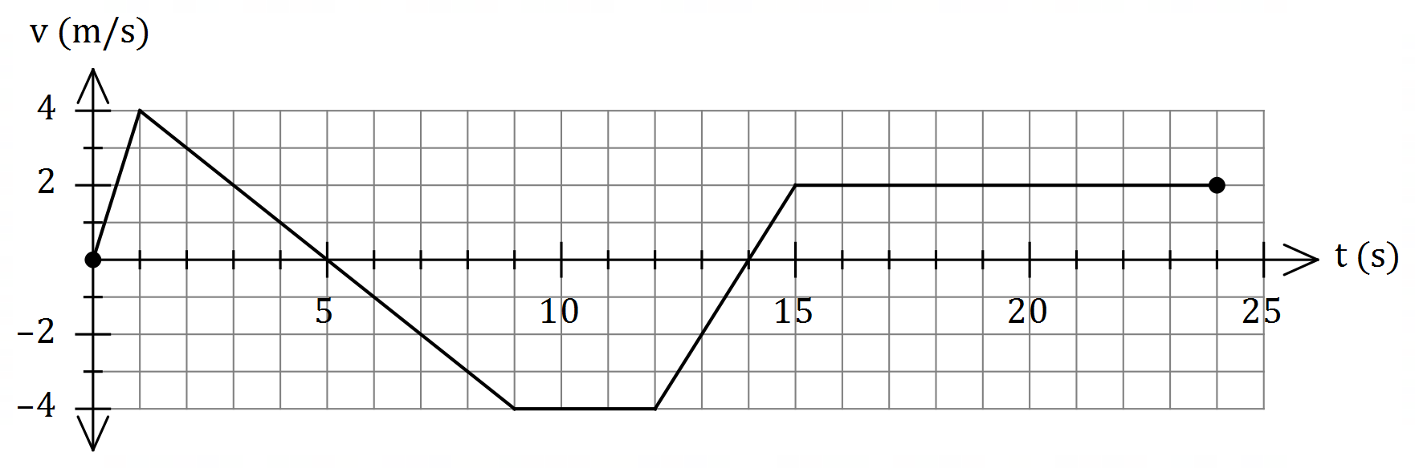

(a) Use the graph to evaluate $\int_{0}^{5}{\underset{ }{\overset{ }{v}}}dt$ and interpret your answer with reference to the motion of the small body. (3 marks)
Solution
$$\int_{0}^{5}{v}dt=\frac{1}{2}×5×4=10 \text{m}$$

The change in displacement of the body during the first $5$ seconds is $10$ m.
OR
The body has moved $10$ m to the right of $P$ during first $5$ seconds.

Specific behaviours
value of integral
✓ interprets as change in displacement
✓ includes specific time and distance with units in interpretation

(b) Determine an expression, in terms of $t$, for the displacement of the body relative to $P$ during the interval $1≤t≤9$. (3 marks)

Solution
$$v=5-t⇒x=\int{5-t}dt=5t-0.5t^{2}+c$$

$$t=1,x=2⇒2=5\left(1\right)-{0.5\left(1\right)}^{2}+c⇒c=-2.5$$

$$x=5t-{0.5t}^{2}-2.5, 1≤t≤9$$

Specific behaviours
expression for $v$
✓ expression for $x$ with constant $c$
✓ correct expression for $x$

(c) Determine the time(s) at which the body was at point $P$ for $0<t≤24$.
(3 marks)
Solution
$$x\left(9\right)=10+\frac{1}{2}×4×\left(-4\right)=2$$
$$2-4\left(t-9\right)=0⇒t=9.5$$

$$x\left(15\right)=-13$$
$$-13+2\left(t-15\right)=0⇒t=21.5$$

Body at point $P$ when $t=9.5$ s and $t=21.5$ s.

Specific behaviours
indicates appropriate method using areas
✓ one correct time
✓ two correct times

Question 15 (9 marks)
A curve has equation $y=\left(x-3\right)e^{2x}$.

(a) Show that the curve has only one stationary point and use an algebraic method to determine its nature. (3 marks)
Solution
$$y^{'}=2xe^{2x}-5e^{2x} \\ =e^{2x}\left(2x-5\right)$$
For stationary point, require $y^{'}=0$ and since $e^{2x}≠0$ then $x=2.5$ - there is only one stationary point.

$$y^{''}=4xe^{2x}-8e^{2x}$$
$$x=2.5⇒y^{''}=2e^{5}$$
Hence stationary point is a local minimum.

Specific behaviours
first derivative
✓ uses factored form to justify one stationary point
✓ indicates minimum using derivatives (sign or 2nd)

(b) Justify that the curve has a point of inflection when $x=2$. (4 marks)
Alternative Solution
$$y^{''}=4e^{2x}\left(x-2\right) \\ y^{''}(2)=4e^{2(2)}\left(2-2\right)=0$$
$$y^{'''}=4e^{2x}\left(2x-3\right) \\ y'''\left(2\right)=4e^{4}$$

Hence point of inflection as $f^{''}\left(2\right)=0$ and $f^{'''}\left(2\right)≠0$.

Specific behaviours
second derivative
shows second derivative is zero
✓ calculates third derivative
✓ explains justification

Solution
$$y^{''}=4e^{2x}\left(x-2\right) \\ y^{''}\left(1.9\right)=4e^{2\left(1.9\right)}\left(1.9-2\right)≈-18 \\ y^{''}(2)=4e^{2(2)}\left(2-2\right)=0 \\ y^{''}\left(2.1\right)=4e^{2\left(2.1\right)}\left(2.1-2\right)≈27$$

Hence point of inflection as concavity changes from $-$ve to $+$ve as $x$ increases through $x=2$.

Specific behaviours
second derivative
shows second derivative is zero
✓ calculates second derivative either side
✓ explains justification

(c) Sketch the curve on the axes below.
(2 marks)
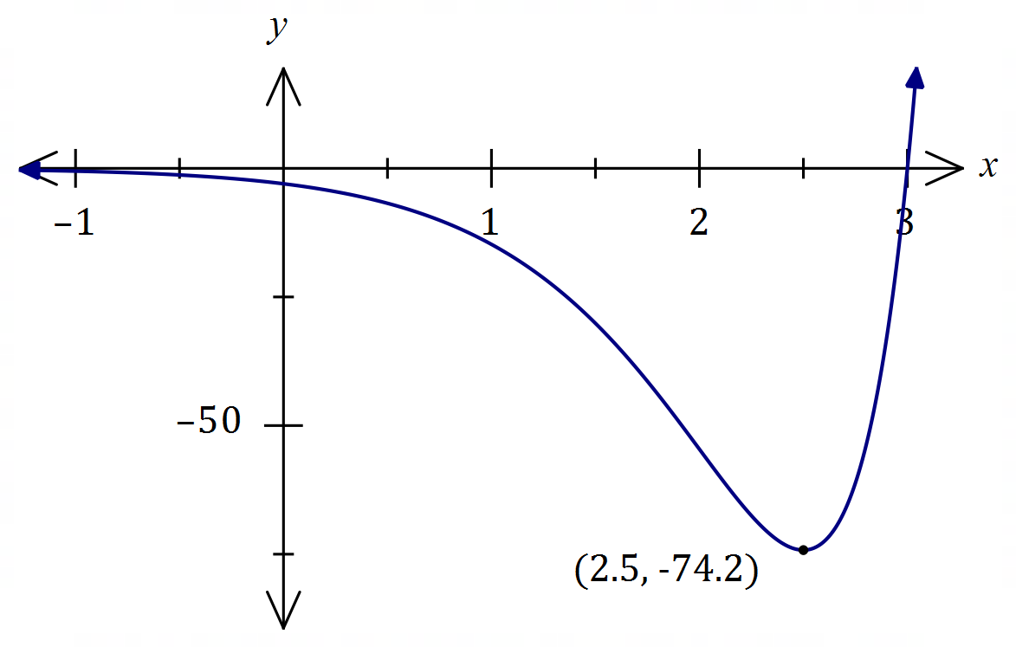
Solution
See graph
Specific behaviours
minimum, $y$-intercept
✓ correct shape

Question 16 (8 marks)
Let $P(a, b)$ be a point in the first quadrant that lies on the curve $y=5-x^{2}$ and $A$ be the area of the triangle formed by the tangent to the curve at $P$ and the coordinate axes.

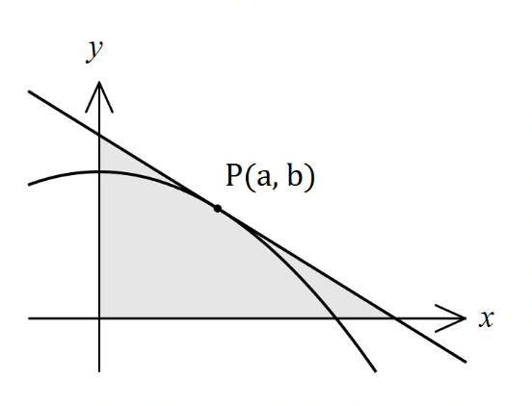

(a) Show that $A=\begin{matrix}{\left(a^{2}+5\right)}^{2} \\ \overline{ 4a }\end{matrix}$.
(4 marks)

Solution
Gradient at $P$:
$$\frac{dy}{dx}=-2x⇒m_{P}=-2a$$
Equation of tangent:
$$y-b=-2a(x-a) \\ y-\left(5-a^{2}\right)=-2ax+2a^{2} \\ y=-2ax+a^{2}+5$$
Axes intercepts:
$$y=0⇒x=\frac{a^{2}+5}{2a}, x=0⇒y=a^{2}+5$$
Area:
$$A=\frac{1}{2}\left(\frac{a^{2}+5}{2a}\right)\left(a^{2}+5\right)=\frac{{\left(a^{2}+5\right)}^{2}}{4a}$$

Specific behaviours
$b$ in terms of $a$ and $m_{P}$
✓ equation of tangent in terms of $a, x, y$ (any form)
✓ axes intercepts
✓ indicates area of right triangle

(b) Use calculus to determine the coordinates of $P$ that minimise $A$.
(4 marks)
Solution
$$\frac{dA}{da}=\frac{3a^{4}+10a^{2}-25}{4a^{2}}$$
$$\frac{dA}{da}=0⇒a=\frac{\sqrt{15}}{3}≈1.291$$

$$\frac{d^{2}A}{da^{2}}={\left.\frac{3a^{4}+25}{2a^{3}}\right|}_{a=\frac{\sqrt{15}}{3}}=2\sqrt{15}⇒\text{Minimum}$$
$$b=5-a^{2}=\frac{10}{3}$$
Hence $P\left(\frac{\sqrt{15}}{3},\frac{10}{3}\right)≈P(1.291, 3.333)$

Specific behaviours
first derivative
✓ solves for $a$
✓ indicates check for minimum (graph, sign or second derivative test)
✓ correct coordinates, exact or at least $2$ dp

Question 17 (8 marks)
(a) The cost of producing x items of a product is given by . Each item is sold for $24.90.

- Determine the profit equation.
(1 mark)

Solution
Specific behaviours
correct profit equation (does not need to be simplified)

Use differentiation to determine

- the profit associated with the sale of the 1001st item.
(3 marks)
Solution
Specific behaviours
derives P
substitutes x = 1000
determines the value of P

(b) Use the increments formula to determine the percentage change in the radius of a cone if the height remains constant and V increase by 3%.
(4 marks)

Solution
Specific behaviours
derives V
values of $δV$
✓ use of increments formula
✓ correct approximation

Question 18 (9 marks)
(a) The rule of the graph below is of the form $y=\log_{2}\left(x-b\right)+c$.
(2 marks)
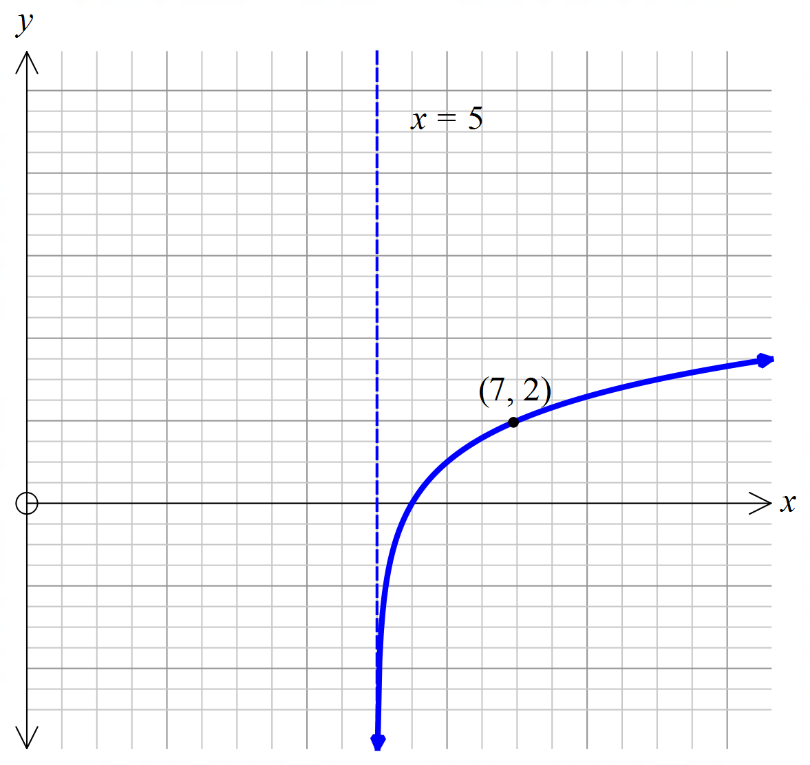

Find the values of $b$ and $c$.

Solution
b = 5 and c = 1
Specific behaviours
correct b
correct c

(b) Draw the graph of the function in the form $y=\log_{3}\left(x-b\right)+c$ which passes through the points (5, 10) and (-1, 9).
(3 marks)
Solution
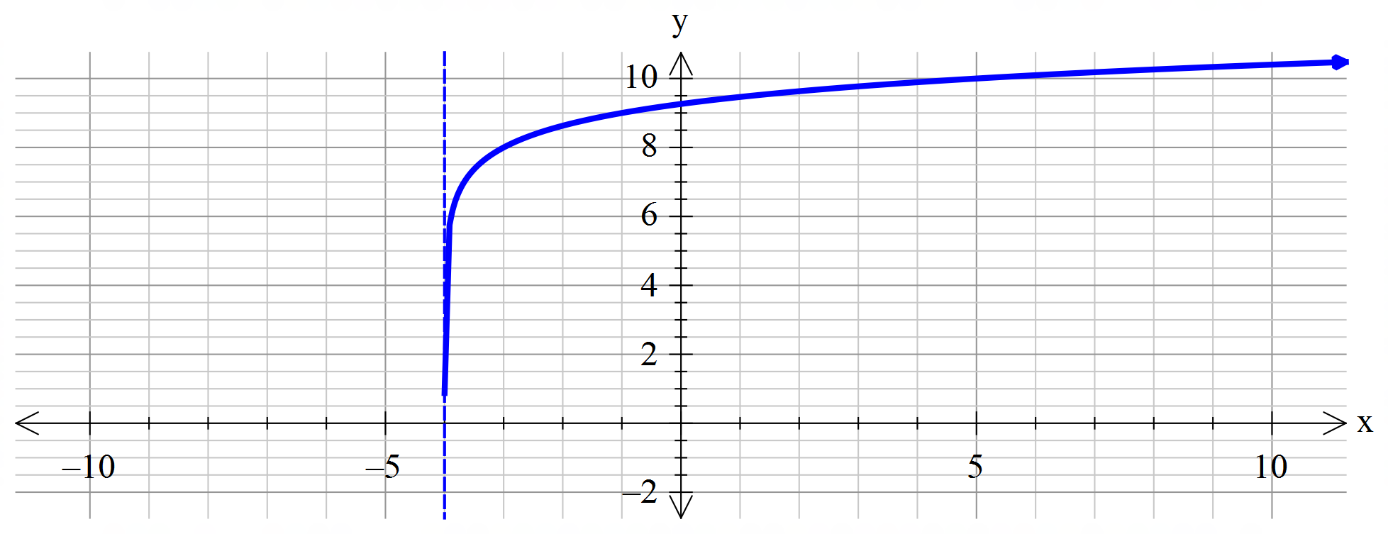
Specific behaviours
correct asymptote shown
accurate sketch
arrows on sketch

- What are the values of $b$ and $c$?
Solution
Specific behaviours
correct b
correct c
(2 marks)

- State the domain and range of the function. (2 marks)

Solution
Specific behaviours
correct domain
correct range

Question 19 (8 marks)
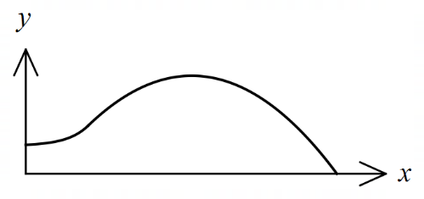
The edges of a swimming pool design, when viewed
from above, are the $x$-axis, the $y$-axis and the curves

$y=-0.1x^{2}+1.6x-1.5$ and $y=1.4+e^{x-3}$

where $x$ and $y$ are measured in metres.

(a) Determine the gradient of the curve at the point where the two curves meet.
(3 marks)
Solution
Curves intersect when $x=3$

$$y^{'}=-0.2\left(3\right)+1.6=e^{3-3}=1$$

Specific behaviours
$x$-coordinate of intersection
✓ derivate of a function
correct gradient

(b) Determine the surface area of the swimming pool. (4 marks)
Solution
$$A_{1}=\int_{0}^{3}{1.4+e^{x-3}}dx=\frac{26}{5}-\frac{1}{e^{3}}≈5.15$$

$$A_{2}=\int_{3}^{15}{-0.1x^{2}+1.6x-1.5}dx=\frac{216}{5}=43.2$$

$$A_{1}+A_{2}=\frac{242}{5}-\frac{1}{e^{3}}≈48.35 {\text{m}}^{2}$$

Specific behaviours
upper bound for parabola
✓ area $A_{1}$
✓ area $A_{2}$
✓ total area, with units

(c) Given that the water in the pool has a uniform depth of $145$ cm, determine the capacity of the pool in kilolitres ($1$ kilolitre of water occupies a volume of $1$ m³).
(1 mark)
Solution
$$C=48.35×1.45≈70.1 \text{kL}$$

Specific behaviours
correct capacity

Question 20 (6 marks)
The moment magnitude scale $M_{w}$ is used by seismologists to measure the size of earthquakes in terms of the energy released. It was developed to succeed the 1930's-era Richter magnitude scale.
The moment magnitude has no units and is defined as $M_{w}=\frac{2}{3}\log_{10}\left(M_{0}\right)-10.7$, where $M_{0}$ is the total amount of energy that is transformed during an earthquake, measured in dyn$∙$cm.

(a) On 28 June 2016, an estimated $2.82×{10}^{21}$ dyn∙cm of energy was transformed during an earthquake near Norseman, WA. Calculate the moment magnitude for this earthquake.
(1 mark)
Solution
$$M_{w}=3.6$$
Specific behaviours
calculates MM

(b) A few days later, on 8 July 2016, there was another earthquake with moment magnitude 5.2 just north of Norseman. Calculate how much energy was transformed during this earthquake. (2 marks)
Solution
$$5.2=\frac{2}{3}\log_{10}{x}-10.7 \\ x=7.08×{10}^{23} \text{dyn}∙\text{cm}$$

Specific behaviours
substitutes
solve for energy

(c) Show that an increase of 2 on the moment magnitude scale corresponds to the transformation of 1000 times more energy during an earthquake. (3 marks)
Solution
$$M_{w}=\frac{2}{3}\log_{10}\left(x\right)-10.7…\left(1\right) \text{and }M_{w}+2=\frac{2}{3}\log_{10}\left(y\right)-10.7…(2)$$

$$\left(2\right)-\left(1\right):2=\frac{2}{3}(\log_{10}{y}-\log_{10}{x})$$

$$\log_{10}{\frac{y}{x}}=3$$

$$\frac{y}{x}={10}^{3}=1000 \text{times greater}$$

Specific behaviours
writes two equations for $M$ and $M+2$
combines the equations for comparison
rearranges equation to show correct answer

NB Max if uses specific values rather than general case

Question 21 (8 marks)

Given that $f\left(-2\right)=-2, f^{'}\left(-2\right)=-1, g\left(-2\right)=4$ and $g^{'}\left(-2\right)=3$, evaluate $h'(-2)$ in each of the following cases.
(a) $h\left(x\right)={\left(f\left(x\right)\right)}^{5}$. (2 marks)
Solution
$$h^{'}\left(-2\right)=5×{\left(f\left(-2\right)\right)}^{4}×f'(-2) \\ =5×{(-2)}^{4}×(-1) \\ =-80$$

Specific behaviours
uses chain rule
✓ correct value

(b) $h\left(x\right)=\begin{matrix}g(x) \\ \overline{f(x)}\end{matrix}$. (2 marks)
Solution
$$h^{'}\left(-2\right)=\frac{g^{'}\left(-2\right)×f\left(-2\right)-g\left(-2\right){×f}^{'}\left(-2\right)}{f{\left(-2\right)}^{2}} \\ =\frac{3×\left(-2\right)-4×\left(-1\right)}{{\left(-2\right)}^{2}} \\ =-\frac{1}{2}$$

Specific behaviours
uses quotient rule
✓ correct value

(c) $h\left(x\right)=g\left(f\left(x\right)\right)$. (2 marks)
Solution
$$h^{'}\left(-2\right)=g^{'}\left(f\left(-2\right)\right)×f^{'}\left(-2\right) \\ =g^{'}\left(-2\right)×f^{'}\left(-2\right) \\ =3×(-1) \\ =-3$$

Specific behaviours
uses chain rule
✓ correct value

